Design Brief: Why ChemE Challenge

Introduction
Students new to chemical engineering are often unsure of what chemical engineers do. They seldom know the scope of potential careers, let alone the career pathway and educational experiences that will make them competitive.
Today, chemical engineers are employed across a wide range of businesses by both large and small companies. Chemical engineering remains one of the best-paying professions in the US with salaries rising by 30% over the last decade. Surveys show that chemical engineers earn more, on average, than other types of engineers and more than research scientists. Chemical engineers have many career opportunities. They perform groundbreaking research, work as field engineers, and occupy senior management positions, just to name a few. Graduates employed by multinational companies often travel all over the world.
Chemical engineers work to improve the quality of people's lives. Their work is needed to produce most items used by people every day. Chemical engineers help to end starvation, disease and poverty. They are working to save the environment by developing alternative technologies to combat acid rain, lead pollution and the greenhouse effect [1].
In this challenge, you will become familiar with career options and pathways for chemical engineers. You will conduct internet research and interview an alumnus, faculty member, graduate student, or industry professional to learn more about their career. You will present your findings in the form of a brochure or video that the UNM CBE Department can use to attract new students to the field of chemical engineering.

Student Learning Outcomes
Students will be able to:
- research at least two chemical engineering career pathways;
- synthesize information gathered from internet research and interviews;
- utilize resources available to chemical engineering students;
- evaluate personal skills and goals to consider future outcomes;
- communicate professionally and persuasively.

Constraints
Information conveyed should be concise and accurate to the best of your ability. While this challenge is largely an individual endeavor, collaboration is key to success and therefore managing relationships and interpersonal communications is vital. You are expected to manage time appropriately so that each element of the challenge is done in a timely manner and fully completed.

Project Deliverables
This challenge includes the following deliverables:
Deliverables | Points
Deliverable 1: Getting started with AIChE  Join AIChE for free as a student and complete 1 module in the SAChE certificate. | 5
Deliverable 2: Engineering pathways research & preparation  Write questions you want to ask an alum about their work and career pathways.  Research one chemical engineering career. | 25
Deliverable 3: SAChE certification from AIChE  Complete remaining modules of Laboratory Safety certification | 25
Deliverable 4: Laboratory Reflection  Submit a short reflection of the laboratory settings you have experienced as well as your thoughts on your potential place within the lab setting by answering the questions found on the deliverable outline. | 10
Deliverable 5: Entering the CBE Community  Attend two CBE events or other engineering events with at least one other CBE student. Write a letter describing the characteristics, interests, and experiences you possess that will make you a great engineer. | 35
Deliverable 6: Engineering Pathways Presentation  Your presentation (brochure, poster or short video) should be professional, informational, and persuasive. It must include information about the career pathway, mindset, typical day, and educational experiences needed for at least two chemical engineering careers. | 50

References
[1] Department of Chemical Engineering and Biotechnology. The University of Cambridge. http://www.ceb.cam.ac.uk/undergraduates/prospective-students/why-study-chemical-engineering. (accessed July 8, 2017)

Why ChemE Deliverable 1

Getting started with AIChE Resources & Safety Training

The American Institute of Chemical Engineers (AIChE) is a professional organization for chemical engineers. It is a powerful resource for chemical engineering students to gain local and national support from their peers and gain professional skills that have long-term benefits.

You will use this resource to gain Safety And Chemical Engineering Education (SAChE) lab safety certification that will demonstrate your ability to uphold safe lab procedures. Not only is this a graduation requirement for chemical engineering, but it is recognized by employers as well.

In this deliverable, you will join AIChE and get started on your SAChE certificate. You’ll complete the certificate later this semester so that you can work in the lab.

Task 1: Join AIChE as a (FREE!) student member
1. Go to www.aiche.org
2. Click on the “Join” tab in the upper right-hand corner:
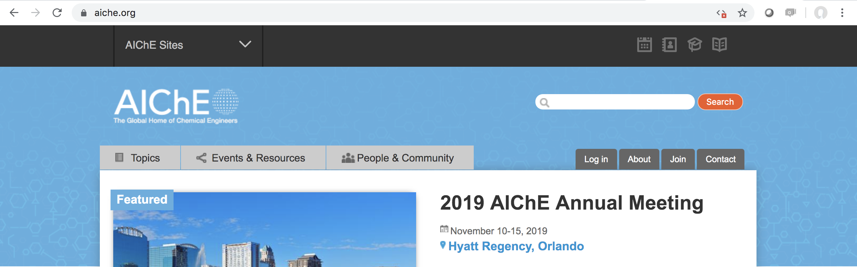

3. Click the “Join now” button:
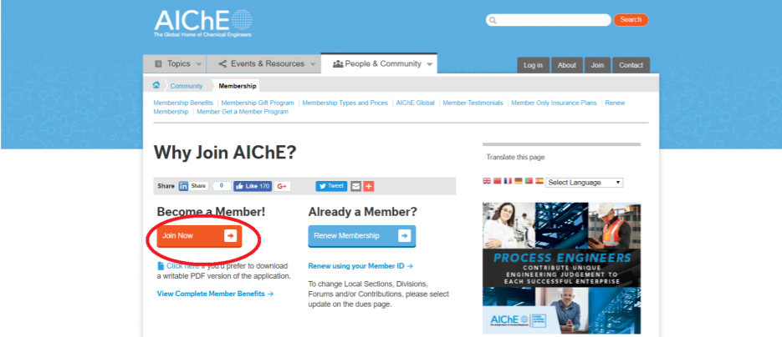

4. Fill out your Profile Information, making sure you keep track of your login and click next.

5. Under Demographic/Education, you MUST check “I am a student” and include “University of New Mexico” “Bachelor” “Chemical Engineering” and your expected graduation date:
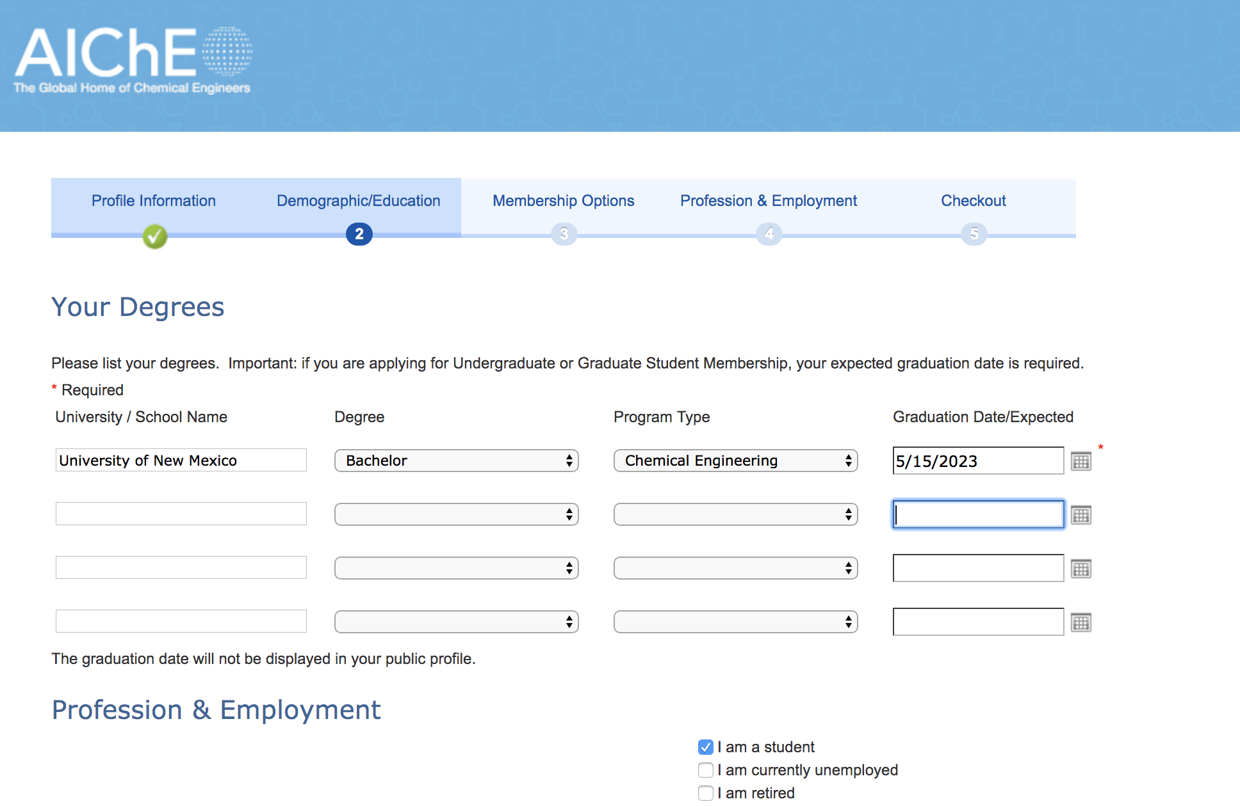
6. Under Membership Options, you can optionally add other Memberships and Forums. Some are free and others add a cost. You should join a division (Free!) most interesting to you. All “Subscriptions” incur a cost. When you check out, the bill should be $0 unless you added a Membership, Forum, or Subscription.

Task 2: Enroll in and complete the first lecture & quiz in the AIChE Certificate in Basics of Laboratory Safety
1. Once you have created an account, login.
First, try to access the course from this link, then skip to step 7 below:
https://www.aiche.org/academy/courses/ela909/sacher-certificate-program-basics-laboratory-safety
If the link does not work, follow the instructions in steps 2-6 first.
2. Click on the “People and Community” tab just below the website banner and select “students” from the far-right column of the dropdown menu
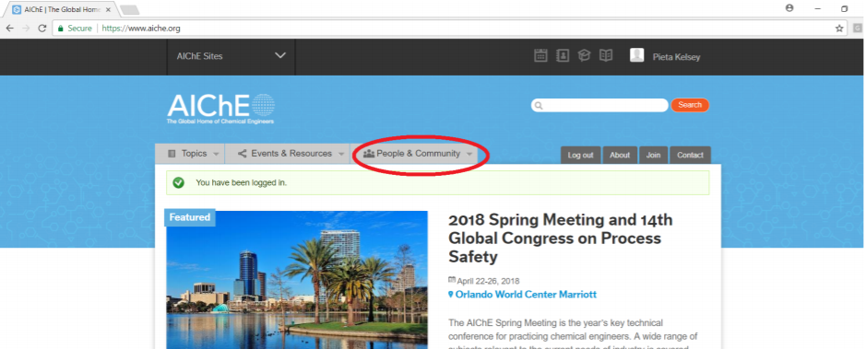

3. Scroll down the page and click “SAChE Safety + Chemical Engineering Education”
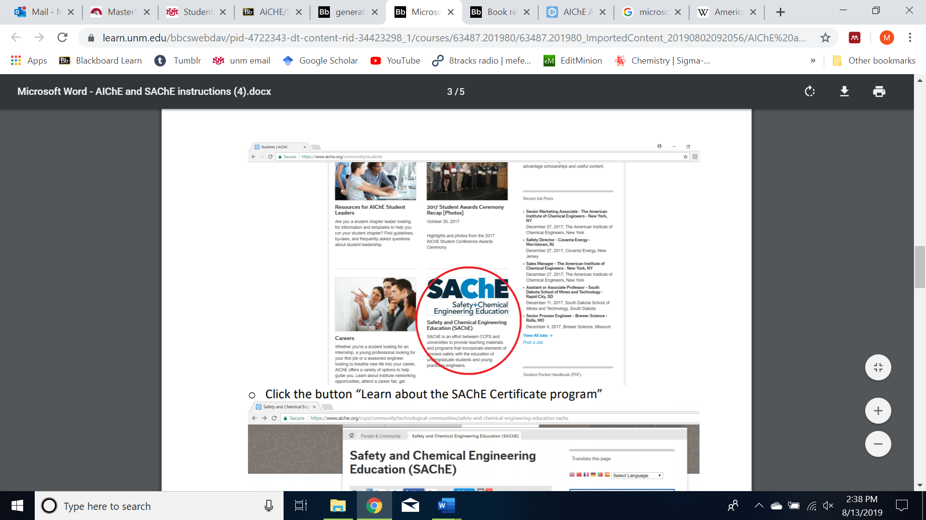

4. Click “Learn about the SAChE Certificate program”
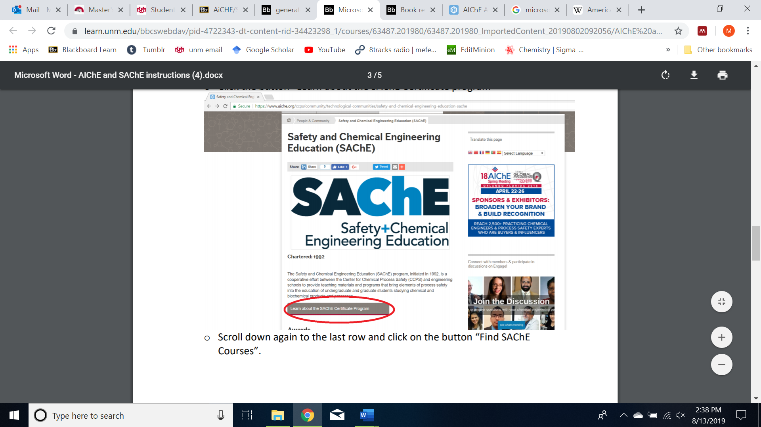

5. Scroll all the way down to “Find SAChE Courses”
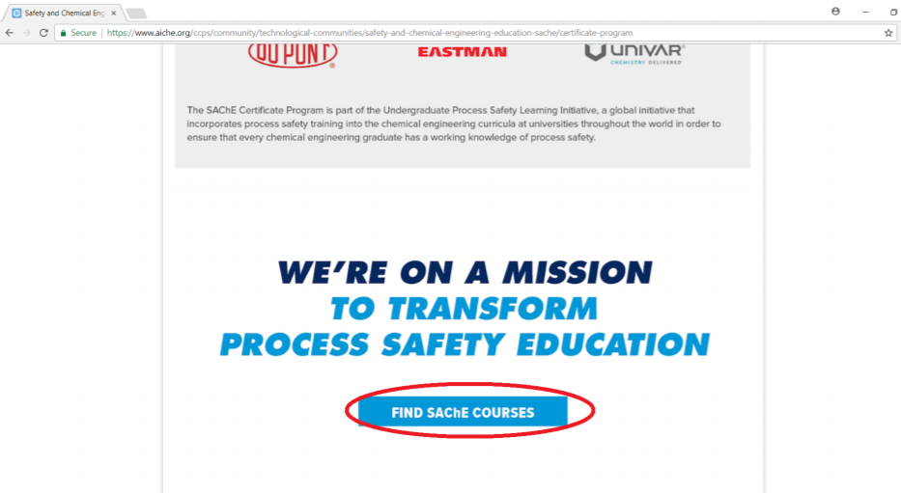

6. Click on “SAChE® Certificate Program - Basics of Laboratory Safety”
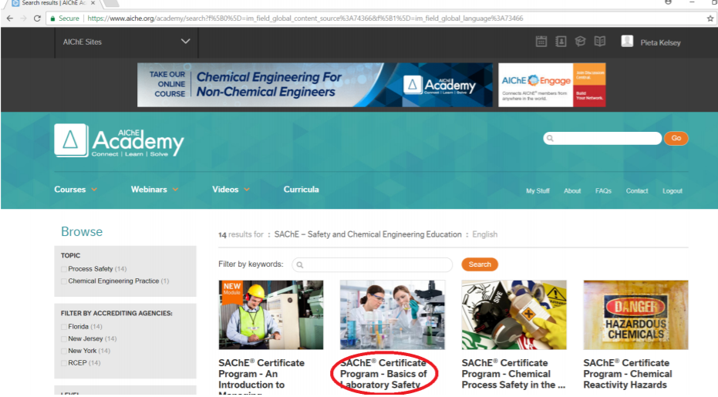

7. Click “Access Course” (You MUST be logged in at this point)
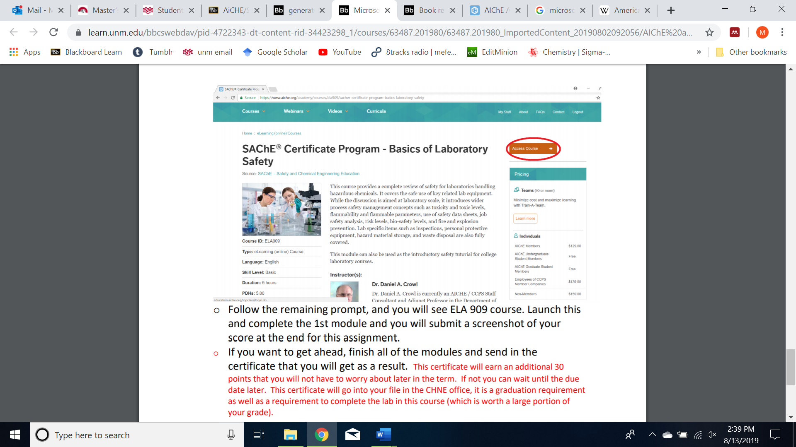

8. Follow the prompts to enter ELA 909 course and launch the first module. The FIRST LECTURE & QUIZ only is due for this deliverable. Upload a screenshot pasted into a word doc to show you completed the first lecture and quiz. The remainder of lectures and quizzes must be completed to earn certification (Why ChemE Deliverable 3).
Your screenshot should look something like this:
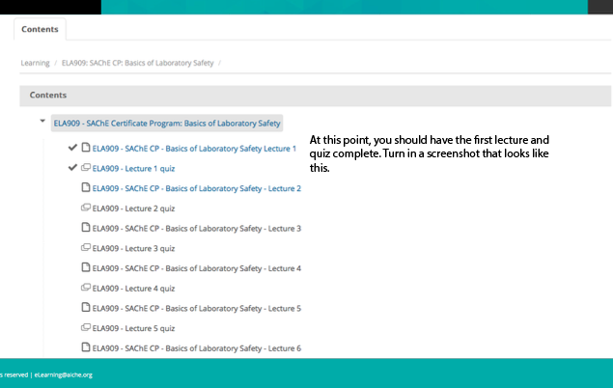

Why ChemE Deliverable 2

Engineering Pathways Research & Preparation
Students new to chemical engineering are often unsure of what chemical engineers do. They seldom know the scope of potential careers, let alone the career pathways, mindset and educational experiences that will make them competitive. Today, chemical engineers are employed across a wide range of businesses by both large and small companies.
Your task is to gather information about chemical engineering career pathways and what chemical engineers do in their work. You will use this information later to produce a brochure or video the CBE department can use to recruit students.

Task 1: Plan interview questions
We will connect you to an alumnus of the CBE department with whom you will conduct an interview (Skype, Zoom, Face Time or telephone conference call) with a few classmates. To prepare for this, you will draft interview questions. In the box below, write at least 5 questions you’d like to ask. Keep in mind that yes/no questions are not very useful. You may want to ask questions about their work, how they got to where they are, internships, or for advice. It is up to you to decide what you want to know.
1.
2.
3.
4.
5.

Task 2: Professional email draft
While alumni are excited to meet UNM CBE undergraduate students, your professional interactions with them can ensure they will stay engaged with students in the future. Part of that means writing professional emails. In the box below, draft an email to the alumnus you will interview. It is okay that you don’t know their name yet. You may write an email to introduce yourself and ask them about their willingness to be interviewed or to thank them for speaking with you.
Subject line:
Email body:

Task 3: Internet research
Conduct internet research to learn more about what chemical engineers do. You should aim to answer the following questions for a specific chemical engineering job:
- What qualifications does someone in this career need to have?
- What kinds of work do they do?
- What is their salary range?
- What is something else that makes the specific job interesting?
- Would you choose this job? Why?
You should look at job advertisements for chemical engineers on the internet, as well as websites that provide information about what chemical engineers do.
Write your notes in the box below, including a link to the website and the title of the website. Find at least three sources:
Source 1:

Source 2:

Source 3:

Image(s)
You will want to include images in your final product that illustrate the career. Follow the guidelines here: http://www.15minutemondays.com/2014/03/10/give-photo-credit-credit-due/.
Citation:
Paste figure here:

Rubric
Deliverable 1 will be graded as follows:
3pts | Task 1. Interview questions  - Questions are open-ended and on topic  - Questions are appropriate and professional
3pts | Task 2. Professional email draft  - Writing conforms to genre expectation (includes subject, greeting, body, closing)  - Tone is professional and respectful but friendly  - Email stays on topic  - The writer has carefully proofread and edited for grammar, spelling and punctuation
4pts | Task 3. Internet research  - Notes are in the students’ own words, not plagiarized  - Citations make it easy to find the information  - Notes provide detail about what chemical engineers do  - Notes provide detail about qualifications needed  - Image follows guidelines provided

Why ChemE Deliverable 3

AIChE Resources and Safety Training

The American Institute of Chemical Engineers (AIChE) is a professional organization for chemical engineers and is a powerful resource for chemical engineering students to gain both local and national support from their peers and gain professional skills that have long-term benefits. You will use this resource to gain Safety And Chemical Engineering Education (SAChE) lab safety certification that will demonstrate your ability to uphold safe lab procedures. Not only is this a graduation requirement for chemical engineering, but it is recognized by employers as well.

In this deliverable, you will complete your SAChE certificate.

Task 1: Complete AIChE Certificate in Laboratory Safety
1. Go to www.aiche.org. Login.
First, try to access the course from this link, then skip to step 7 below:
https://www.aiche.org/academy/courses/ela909/sacher-certificate-program-basics-laboratory-safety
If the link does not work, follow the instructions in steps 2-6 first.
2. Click on the “People and Community” tab just below the website banner and select “students” from the far-right column of the dropdown menu

3. Scroll down the page and click “SAChE Safety + Chemical Engineering Education”

4. Click “Learn about the SAChE Certificate program”

5. Scroll all the way down to “Find SAChE Courses”

6. Click on “SAChE® Certificate Program - Basics of Laboratory Safety”

7. Click “Access Course” (You MUST be logged in at this point)

8. Follow the prompts to enter ELA 909 course and launch the modules. Earlier, you should have completed the first module. Now you need to recomplete the rest of the modules to you’re your certification. Your certificate should look something like this:

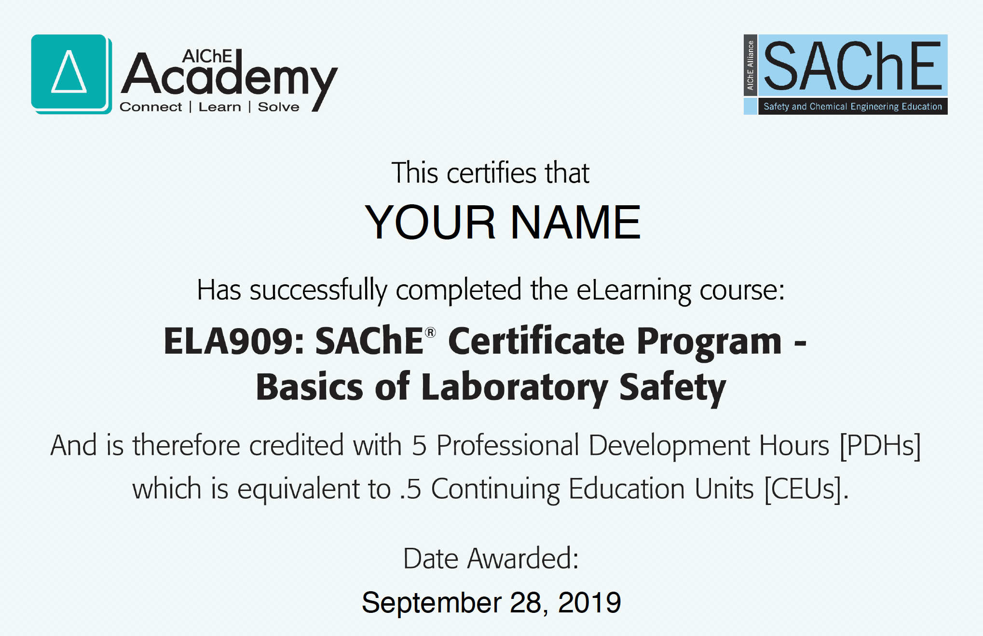

Why ChemE Deliverable 4

Lab Tour Reflection
Understanding the breadth of work that chemical engineers do here at UNM is key to exploring all the possible opportunities available to you during your academic tenure. We hope that you enjoyed exploring some of the labs here on campus. You have seen different equipment, laboratory settings, and research goals that you can use to begin to explore the types of work you are most interested in.

Deliverable: Reflection
Answer the following questions and upload this word file to get credit for your attendance during the lab tour.
- What interested you most about visiting the labs?
- What are a few things you learned during the lab visits?
- What did you like the most about the labs?
- Which lab would you be most interested in working in? Why?

Why ChemE Deliverable 5

Entering the CBE Community

Studies have consistently shown that you are more likely to stay in chemical engineering and enjoy yourself if you are part of the community [1]. To this end, we are asking you to attend CBE events or School of Engineering events with at least one other CBE student. These are the students that you will spend many classes working with in groups, studying for tests with and working alongside in the lab, meaning that the earlier you begin to form relationships, the better off you will be in the long run.

Task 1: Document your attendance at two events
Attend two events as follows:
- Events hosted by CBE
- School of Engineering or other engineering events with at least one other CBE student
- Other relevant events, such as by Innovation Academy, with at least one other CBE student
Use a social media check-in, a hashtag (#UNMCBE101) or selfie to document your attendance along with a short description of the event (i.e., when and where did you?)

Task 2: Letter
During the year, you have attended CBE events, such as the Welcome Back Ice Cream Social, weekly seminar series, student AIChE chapter meetings, or other student organization meetings in engineering. You have had opportunities to meet CBE faculty and students and visit their labs. You have worked on design challenges and learned about what chemical engineers do. Now, you are going to write a short letter reflecting on your experiences.
Compose a 1-page typed, single-space letter describing characteristics, interests, and experiences you possess that will make you a great engineer. You can address the letter to
- someone you know who is interested in why you are considering becoming an engineer
- a potential employer who might hire you for an engineering job or internship
- a faculty member who might hire you to work in their lab
- yourself, to read at a point when you are worried you won’t be successful in engineering
Your letter should contain the following elements:
- Begin with a greeting that makes it clear who you are writing the letter to.
- Explain the purpose of your letter.
- Introduce yourself. Include a short statement about you interests, background and aspirations.
- Explain why you decided to take CBE 101 and why you are interested in becoming an engineer.
- Provide an example from one of your experiences in CBE 101 or other engineering activities you have done that illustrate why you will be successful.
- End by restating how your background makes you a good fit.
Citations
[1] Cross, Susan E., and Niki V. Vick. “The Interdependent Self-Construal and Social Support: The Case of Persistence in Engineering.” Personality and Social Psychology Bulletin 27, no. 7 (July 2001): 820–32.

Why ChemE Deliverable 6
Engineering Pathways Presentation
You will use the information you have gained through interview and internet research and your experiences this semester to create recruitment materials for future CBE students. Your final design can be presented in the form of a brochure, poster or short video. The product should be informative and attractive to incoming students.
Task 1: Recruitment material
Design a CBE recruitment brochure, poster or short video. It will be used to recruit future ChemE students just like you, so, think about what they would want to know.
Consider your audiences and what they might not know about ChemE as a major and as a career.
- High school students
- First year students
- Parents
- Guidance counselors
- Teachers
- UNM advisors

General guidelines
- Capture and keep the attention of your viewer/reader through a succinct narrative.
- Showcase the degree/careers as appealing
- A means for your viewer/reader to get more information (e.g. web address or email)
- Incorporate the UNM/CBE logo
- Only use direct quotes from the alum you interviewed IF YOU HAVE PERMISSION
- Design the product so that it is engaging and clear. Space/time is a premium in these short documents, meaning that visuals and words need to be carefully considered to get the most out of the medium.
- Consider a one-line benefit statement that is the most important message your audience needs to know.
- Show more than tell. Incorporate charts and/or pictures, but make sure all images are cited appropriately: http://www.15minutemondays.com/2014/03/10/give-photo-credit-credit-due/
- Do thorough research. If you know clearly the information you want to convey, you will more effectively communicate to your audience and avoid confusion for your viewer.

If you choose to design a video:
- The audio clarity must be very good!
- Max of two minutes

If you choose to design a flyer or poster:
- Your product should be one full page
- Text must be legible
- Figures must be clear

Tips
Microsoft Office has a number of templates for making flyers/brochures. You may want to do an internet search for tips or You Tube videos on how to make your finished product look professional.
Below are some websites you may find helpful with guidelines and templates:
- https://www.canva.com/templates/flyers/
- https://spark.adobe.com/make/flyer-maker
- https://templates.office.com/en-us/Flyers
- http://www.stocklayouts.com/Templates/Free-Templates/Free-Sample-Flyer-Template-Design.aspx
- https://www.canva.com/templates/brochures/
- https://templates.office.com/en-us/Brochures
- https://www.psprint.com/design-templates/brochures/
- http://newprairiepress.org/cgi/viewcontent.cgi?article=1007&context=ebooks

