Design Challenge: Kirtland Airforce Base Jet Fuel Spill

Introduction
The jet fuel spill in Albuquerque, New Mexico at Kirtland Air Force Base occurred in the Bulk Fuels Facility located in the northwestern part of the base. The facility operated between 1953 and 1999. Within this period, the fueling area was separated into two areas: one designated to be a tank holding area where bulk shipments of fuel were received, and the other was a fuel loading area where fuel trucks would be refilled. The Bulk Fuels Facility was no longer in service when an underground leakage of residual jet fuel was identified in 1999 between the storage tank and fuel loading area. The leak was due to corrosion of the underground delivery pipes^{[1]}.

Research conducted between 2004 and 2007 revealed that the leaked fuel had reached the groundwater table. The leak has a tremendous effect on the surrounding community. If the groundwater were to not be treated on time or be left untreated, ethylene dibromide (EDB), a suspected carcinogen in the jet fuel would reach surrounding communities. The ingestion of this chemical may lead to depression, reproductive malfunctions, and fetal death^{[2]}.

Currently, engineers at the base are attempting to remediate the situation by building monitoring wells in neighborhoods surrounding the base to gauge the course of direction of the fuel and how far the fuel has traveled. These wells utilize pumps to draw samples of water which are then transported back to the treatment facility to test if EDB is present. The drawback to this technique is that the drilling and pumps used for pulling the water from the ground cause noise pollution that disturbs the surrounding communities.

Your goal is to design a way to detect the fuel spill, contain the fuel spill, map out water and treatment locations, and remediate the contaminated soil and water. This challenge will apply principal concepts in chemical engineering, including fluid mechanics and mass, energy, and force balances to a real-world problem. As an engineer, you must adhere to multiple constraints including legal, community, and design constraints. You will have to consider how to design devices that will allow for water collection and sampling throughout the city without disturbing the community and how to design a fuel delivery and storage system that follows set parameter constraints.

Student Learning Outcomes
- Apply engineering Bernoulli's equation to relate pressure and velocity changes, calculate the exit velocity of a fluid through a tank/pipe, and estimating the time it takes to drain a tank.

- Apply Reynolds theorem to solve a variety of engineering problems such as fluid drainage from a tank.

- Utilize Navier-Stokes and continuity equations to describe the motion of jet fuel leakage and determine the horsepower required to transport the jet fuel.

- Apply control volumes and boundary conditions based upon the constraints of the problem.

- Utilize the Moody chart and Reynolds number to determine head loss.

Project Roles
All members of the team are responsible for all information, and every member should participate in making design decisions. Team members’ responsibilities could be broken down to:

Project Manager: Responsible for developing group action plan and keeping group on task. Organizes and submits deliverables. Monitors team’s shared understanding of project. Ensures that team members have the information they need to be effective in their roles.
Environmental engineer: Oversees research on the problem, including the impact on natural and human resources. Communicates with team members to ensures that water treatment facilities and wells are placed along the appropriate property lines to avoid disruption of the community and the environment.
Chemist: Oversees research on jet fuel components and which components in addition to ethylene dibromide may be harmful to the surrounding human and animal population and which compounds are detrimental to piping and storage materials. Coordinates with team members to determine what kind of material is needed in the design to prevent jet fuel from leaking and what further chemicals in the contaminated water will need to be removed.
Chemical Engineer: Oversees delivery piping and storage tank design. Responsible for creating a design that can prevent future leaks, including better containment and swifter detection of leaks. Coordinates with team members to design a system that contains appropriate materials, is safe for the environment and the community, and is legally sound.

References
[1] Kirtland AFB Bulk Fuels Facility Leak Project. (2015). “Kirtland Jet Fuel Remediation.” Retrieved from http://www.kirtlandjetfuelremediation.com/project/sitehistory.htm
[2] United States Environmental Protection Agency. (2016). “Ethylene Dibromide (Dibromoethane).” Retrieved from https://www.epa.gov/sites/production/files/2016 09/documents/ethylene-dibromide.pdf.

Problem 1 – Week 1
Imagine you are a newly hired Air Force engineer working on Kirtland Air Force Base. You have been tasked with a few of the design elements for the jet fuel storage tank system. You have a 30-ft tall cylindrical tank with a diameter of 15 ft, which has been filled to 20 ft with Jet A (ρ = 6.71 lbm/gal).
(a) Calculate the hydrostatic pressure at the bottom of the tank. Give your answer in psig.
(b) Calculate the total force exerted on the vertical walls of the tank due to hydrostatic pressure. Give your answer in lbf.

Problem 2 – Week 2
The Kirtland AFB leak is responsible for spilling an estimated 24 million gallons of jet fuel over a 45-year period. Imagine you are tasked with replacing the faulty fuels facility. Do some research to answer the following questions (Make sure to cite your sources):

- What year was the faulty KAFB fuels facility built? What kind of spill prevention and detection technology existed at that time?
- When and how was the KAFB leak initially detected?
- What was the initial cause of the KAFB leak?
- Why did the leak go undetected for so long?
- What kind of fuel spill prevention and detection technology exists today (study the technology used in gas stations)? Which technologies should have been implemented at KAFB?
- How does modern spill prevention and detection technology work? What kind of information does it produce?

Problem 3 – Week 3
Suppose you are the operations manager for a jet fueling station on an air force base. You have just received a shipment of 200,000 gallons of jet fuel, which equally fills two above ground tanks measuring 30 feet in height and 30 feet in diameter. The two tanks are NOT connected. One of your employees informs you that he has discovered a small corroded section 5 feet above the bottom of one of the tanks. Each tank has an outlet pipe located at the bottom of the tank. The outlet pipe is 3 in in diameter. You first decide to do a rough calculation for the amount of time it would take to drain the tank to 5 feet above the bottom without the leak. The purpose is to indirectly detect if the corroded section is leaking. That is, the drainage time would be less if there is an actual leak. Assume the tanks are open to the atmosphere, and the leak would have a negligible impact on the flow rate out of the outlet pipe.

Problem 4 – Week 4
Sludge is being pumped directly from an underground source at 200 lb_{m}/s through a pipe with a radius of 4 inches. It flows through into a joint which directs the sludge into one of two tanks. Tank 1 is 10ft tall with a 3ft radius and Tank 2 has a volume of 2,250 gallons. Assume frictionless, steady-state flow. Sludge is comprised of mostly water with density 62.4 lb_{m}/ft³.
- Assuming even distribution of flow, which tank fills first?
- What force would be required to hold a T-joint pipe fitting in place?
- What force would be required to hold a Y-joint pipe in place as depicted below?
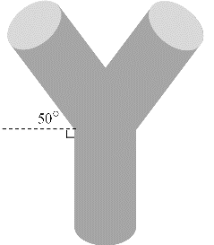
- Which type of joint would be more practical for use and why?
Problem 5 – Week 5
One potential method for remediating the EDB and other toxic chemicals from the groundwater is by pumping the water out of the ground using a well, treating the tainted water and pumping it back into the ground. While expensive, it may represent the only feasible remediation method available.
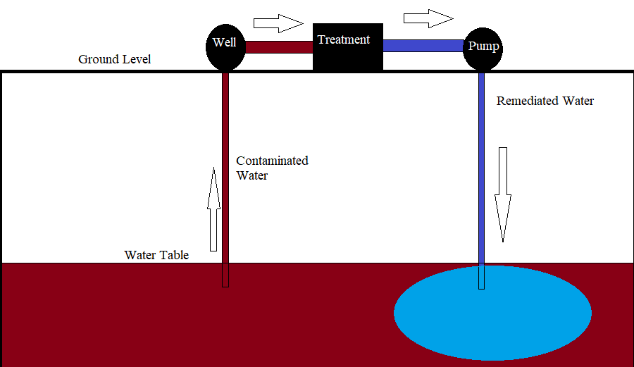

- Assuming the flow in the pipes is laminar, draw and describe the expected velocity profile inside of the pipes. This is qualitative description.
- The contaminated groundwater is 52°F. What is its viscosity and density?
- Look up the velocity profile for laminar flow in pipes. The pipes in our system have a 5.5 inch inner diameter and if V_{max} is 1.6 ft/s. Calculate _{rz}. That is, what is the shear stress that is applied at the pipe walls?

